Task 5

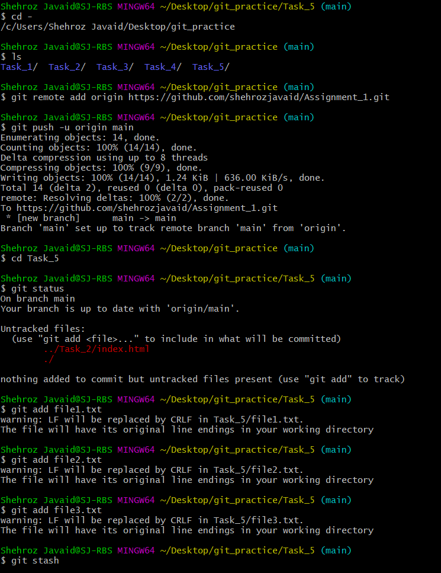

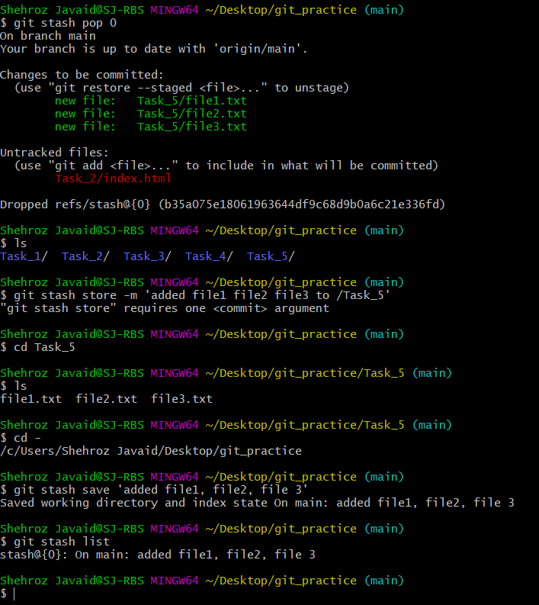

Task 6

Shehroz Javaid@SJ-RBS MINGW64 ~/Desktop/git_practice/Task_6 (main)

$ git log --oneline

4daa99f (HEAD -> main) commit for task 6

f16658c (origin/main) added .gitignore

323dec4 Adding index.html and about.html

9854777 File about.html added

90ac34d Initial Message

Shehroz Javaid@SJ-RBS MINGW64 ~/Desktop/git_practice/Task_6 (main)

$ git reset --soft HEAD~1

Shehroz Javaid@SJ-RBS MINGW64 ~/Desktop/git_practice/Task_6 (main)

$ git log --oneline

f16658c (HEAD -> main, origin/main) added .gitignore

323dec4 Adding index.html and about.html

9854777 File about.html added

90ac34d Initial Message

Shehroz Javaid@SJ-RBS MINGW64 ~/Desktop/git_practice/Task_6 (main)

$

Task 7

Shehroz Javaid@SJ-RBS MINGW64 ~/Desktop/git_practice (main)

$ mkdir Task_7

Shehroz Javaid@SJ-RBS MINGW64 ~/Desktop/git_practice (main)

$ cd Task_7

Shehroz Javaid@SJ-RBS MINGW64 ~/Desktop/git_practice/Task_7 (main)

$ touch file4.txt

Shehroz Javaid@SJ-RBS MINGW64 ~/Desktop/git_practice/Task_7 (main)

$ vim file4.txt

Shehroz Javaid@SJ-RBS MINGW64 ~/Desktop/git_practice/Task_7 (main)

$ cat file4.txt

this is file4 for task_7

Shehroz Javaid@SJ-RBS MINGW64 ~/Desktop/git_practice/Task_7 (main)

$ git add file4.txt

warning: LF will be replaced by CRLF in Task_7/file4.txt.

The file will have its original line endings in your working directory

Shehroz Javaid@SJ-RBS MINGW64 ~/Desktop/git_practice/Task_7 (main)

$ git commit -m 'commit for task_7'

[main b56cc18] commit for task_7

1 file changed, 1 insertion(+)

create mode 100644 Task_7/file4.txt

Shehroz Javaid@SJ-RBS MINGW64 ~/Desktop/git_practice/Task_7 (main)

$ git log --oneline

b56cc18 (HEAD -> main) commit for task_7

f16658c (origin/main) added .gitignore

323dec4 Adding index.html and about.html

9854777 File about.html added

90ac34d Initial Message

Shehroz Javaid@SJ-RBS MINGW64 ~/Desktop/git_practice/Task_7 (main)

$ git reset --hard HEAD~1

HEAD is now at f16658c added .gitignore

Shehroz Javaid@SJ-RBS MINGW64 ~/Desktop/git_practice (main)

$ git log --oneline

f16658c (HEAD -> main, origin/main) added .gitignore

323dec4 Adding index.html and about.html

9854777 File about.html added

90ac34d Initial Message

Shehroz Javaid@SJ-RBS MINGW64 ~/Desktop/git_practice/Task_8 (main)

$ git branch

* main

Shehroz Javaid@SJ-RBS MINGW64 ~/Desktop/git_practice/Task_8 (main)

$ git checkout -b my-feature

Switched to a new branch 'my-feature'

Shehroz Javaid@SJ-RBS MINGW64 ~/Desktop/git_practice/Task_8 (my-feature)

$ git checkout main

Switched to branch 'main'

A Task_8/index.html

Your branch is up to date with 'origin/main'.

Shehroz Javaid@SJ-RBS MINGW64 ~/Desktop/git_practice/Task_8 (main)

$ ls

index.html

Shehroz Javaid@SJ-RBS MINGW64 ~/Desktop/git_practice/Task_8 (main)

$ git commit

Aborting commit due to empty commit message.

Shehroz Javaid@SJ-RBS MINGW64 ~/Desktop/git_practice/Task_8 (main)

$ git commit -m 'Commit for task_8 main branch'

[main c1df38a] Commit for task_8 main branch

1 file changed, 9 insertions(+)

create mode 100644 Task_8/index.html

Shehroz Javaid@SJ-RBS MINGW64 ~/Desktop/git_practice/Task_8 (main)

$ git checkout my-feature

Switched to branch 'my-feature'

Shehroz Javaid@SJ-RBS MINGW64 ~/Desktop/git_practice/Task_8

$ git checkout my-feature

fatal: failed to stat 'C:/Users/Shehroz Javaid/Desktop/git_practice/Task_8': Permission denied

Shehroz Javaid@SJ-RBS MINGW64 ~/Desktop/git_practice/Task_8

$ cd -

/c/Users/Shehroz Javaid/Desktop/git_practice

Shehroz Javaid@SJ-RBS MINGW64 ~/Desktop/git_practice (my-feature)

$ cd -

bash: cd: /c/Users/Shehroz Javaid/Desktop/git_practice/Task_8: No such file or directory

Shehroz Javaid@SJ-RBS MINGW64 ~/Desktop/git_practice (my-feature)

$ cd Task_8

bash: cd: Task_8: No such file or directory

Shehroz Javaid@SJ-RBS MINGW64 ~/Desktop/git_practice (my-feature)

$ ls

Task_1/ Task_2/ Task_3/ Task_4/ Task_6/

Shehroz Javaid@SJ-RBS MINGW64 ~/Desktop/git_practice (my-feature)

$ git checkout main

Switched to branch 'main'

Your branch is ahead of 'origin/main' by 1 commit.

(use "git push" to publish your local commits)

Shehroz Javaid@SJ-RBS MINGW64 ~/Desktop/git_practice (main)

$ ls

Task_1/ Task_2/ Task_3/ Task_4/ Task_6/ Task_8/

Shehroz Javaid@SJ-RBS MINGW64 ~/Desktop/git_practice (main)

$ git checkout my-feature

Switched to branch 'my-feature'

Shehroz Javaid@SJ-RBS MINGW64 ~/Desktop/git_practice (my-feature)

$ mkdir Task_8

Shehroz Javaid@SJ-RBS MINGW64 ~/Desktop/git_practice (my-feature)

$ cd Task_8

Shehroz Javaid@SJ-RBS MINGW64 ~/Desktop/git_practice/Task_8 (my-feature)

$ touch about-us.html

Shehroz Javaid@SJ-RBS MINGW64 ~/Desktop/git_practice/Task_8 (my-feature)

$ vim about-us.html

Shehroz Javaid@SJ-RBS MINGW64 ~/Desktop/git_practice/Task_8 (my-feature)

$ vim about-us.html

Shehroz Javaid@SJ-RBS MINGW64 ~/Desktop/git_practice/Task_8 (my-feature)

$ add about-us.html

bash: add: command not found

Shehroz Javaid@SJ-RBS MINGW64 ~/Desktop/git_practice/Task_8 (my-feature)

$ git add about-us.html

warning: LF will be replaced by CRLF in Task_8/about-us.html.

The file will have its original line endings in your working directory

Shehroz Javaid@SJ-RBS MINGW64 ~/Desktop/git_practice/Task_8 (my-feature)

$ git log --oneline

f16658c (HEAD -> my-feature, origin/main) added .gitignore

323dec4 Adding index.html and about.html

9854777 File about.html added

90ac34d Initial Message

Shehroz Javaid@SJ-RBS MINGW64 ~/Desktop/git_practice/Task_8 (my-feature)

$ git status

On branch my-feature

Changes to be committed:

(use "git restore --staged <file>..." to unstage)

new file: about-us.html

Untracked files:

(use "git add <file>..." to include in what will be committed)

../Task_2/index.html

../Task_6/

Shehroz Javaid@SJ-RBS MINGW64 ~/Desktop/git_practice/Task_8 (my-feature)

$ git commit -m 'commit for task_8 from my-feature branch'

[my-feature d8f0d6e] commit for task_8 from my-feature branch

1 file changed, 9 insertions(+)

create mode 100644 Task_8/about-us.html

Shehroz Javaid@SJ-RBS MINGW64 ~/Desktop/git_practice/Task_8 (my-feature)

$ git checkout main

fatal: cannot create directory at 'Task_8': Permission denied

Shehroz Javaid@SJ-RBS MINGW64 ~/Desktop/git_practice/Task_8

$ cd -

/c/Users/Shehroz Javaid/Desktop/git_practice

Shehroz Javaid@SJ-RBS MINGW64 ~/Desktop/git_practice (my-feature)

$ git checkout main

Switched to branch 'main'

Your branch is ahead of 'origin/main' by 1 commit.

(use "git push" to publish your local commits)

Shehroz Javaid@SJ-RBS MINGW64 ~/Desktop/git_practice (main)

$ ls

Task_1/ Task_2/ Task_3/ Task_4/ Task_6/ Task_8/

Shehroz Javaid@SJ-RBS MINGW64 ~/Desktop/git_practice (main)

$ cd Task_8

Shehroz Javaid@SJ-RBS MINGW64 ~/Desktop/git_practice/Task_8 (main)

$ ls

index.html

Shehroz Javaid@SJ-RBS MINGW64 ~/Desktop/git_practice/Task_8 (main)

$ cd -

/c/Users/Shehroz Javaid/Desktop/git_practice

Shehroz Javaid@SJ-RBS MINGW64 ~/Desktop/git_practice (main)

$ git merge my-feature

Merge made by the 'recursive' strategy.

Task_8/about-us.html | 9 +++++++++

1 file changed, 9 insertions(+)

create mode 100644 Task_8/about-us.html

Shehroz Javaid@SJ-RBS MINGW64 ~/Desktop/git_practice (main)

$ git log --oneline

79213e6 (HEAD -> main) Merge branch 'my-feature'

d8f0d6e (my-feature) commit for task_8 from my-feature branch

c1df38a Commit for task_8 main branch

f16658c (origin/main) added .gitignore

323dec4 Adding index.html and about.html

9854777 File about.html added

90ac34d Initial Message

Shehroz Javaid@SJ-RBS MINGW64 ~/Desktop/git_practice (main)

$

Shehroz Javaid@SJ-RBS MINGW64 ~/Desktop/git_practice/Task_8 (main)

$ ls

about-us.html index.html

Shehroz Javaid@SJ-RBS MINGW64 ~/Desktop/git_practice/Task_8 (main)

$

Task 9

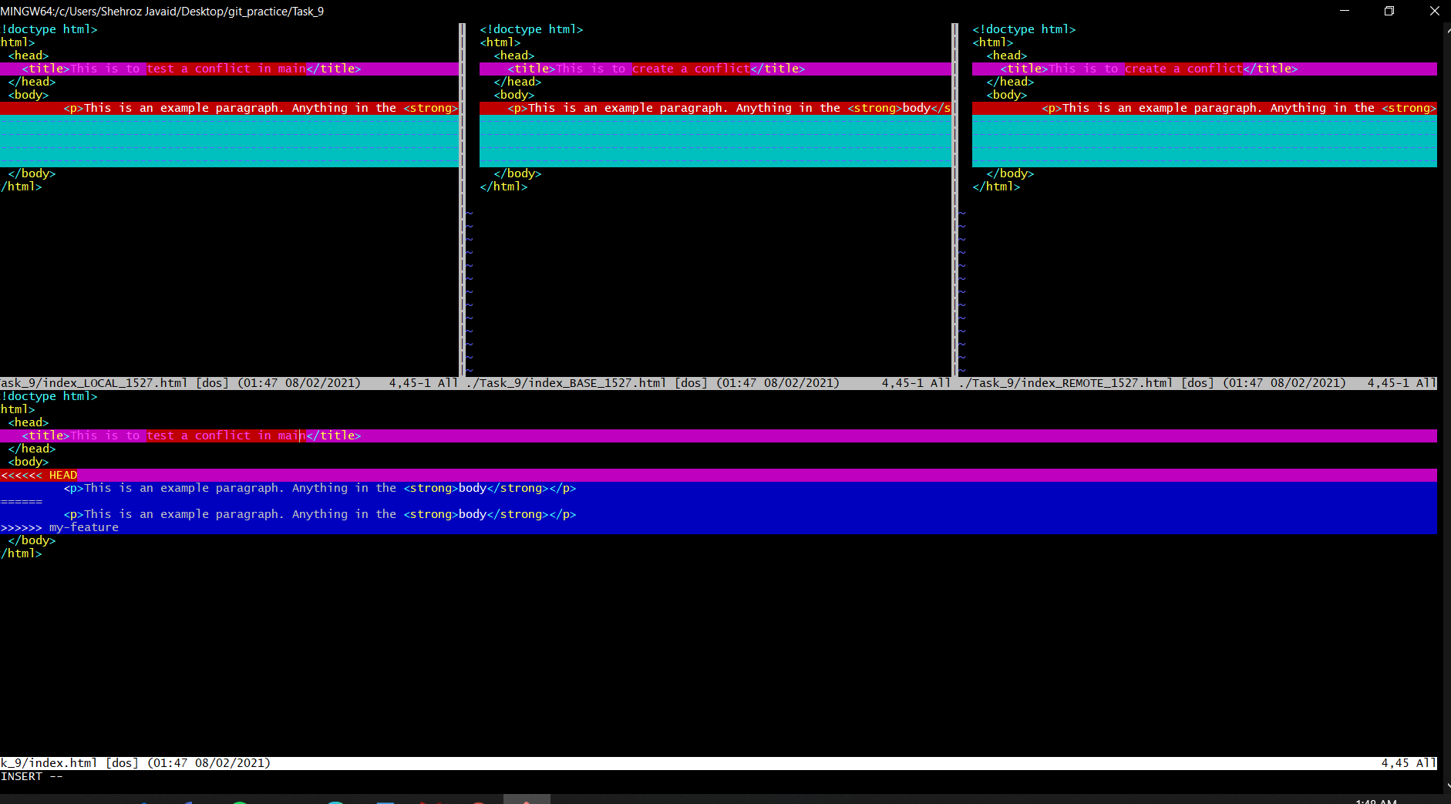

Shehroz Javaid@SJ-RBS MINGW64 ~/Desktop

$ cd git_practice

Shehroz Javaid@SJ-RBS MINGW64 ~/Desktop/git_practice (main)

$ git log --oneline

f16658c (HEAD -> main, origin/main) added .gitignore

323dec4 Adding index.html and about.html

9854777 File about.html added

90ac34d Initial Message

Shehroz Javaid@SJ-RBS MINGW64 ~/Desktop/git_practice (main)

$ ^C

Shehroz Javaid@SJ-RBS MINGW64 ~/Desktop/git_practice (main)

$ ls

Task_1/ Task_2/ Task_3/ Task_4/ Task_6/

Shehroz Javaid@SJ-RBS MINGW64 ~/Desktop/git_practice (main)

$ git push origin main

Everything up-to-date

Shehroz Javaid@SJ-RBS MINGW64 ~/Desktop/git_practice (main)

$ mkdir Task_8

Shehroz Javaid@SJ-RBS MINGW64 ~/Desktop/git_practice (main)

$ cd Task_8

Shehroz Javaid@SJ-RBS MINGW64 ~/Desktop/git_practice/Task_8 (main)

$ touch index.html

Shehroz Javaid@SJ-RBS MINGW64 ~/Desktop/git_practice/Task_8 (main)

$ touch index.html

Shehroz Javaid@SJ-RBS MINGW64 ~/Desktop/git_practice/Task_8 (main)

$ ls

index.html

Shehroz Javaid@SJ-RBS MINGW64 ~/Desktop/git_practice/Task_8 (main)

$ vim index.html

Shehroz Javaid@SJ-RBS MINGW64 ~/Desktop/git_practice/Task_8 (main)

$ vim index.html

Shehroz Javaid@SJ-RBS MINGW64 ~/Desktop/git_practice/Task_8 (main)

$ add index.html

bash: add: command not found

Shehroz Javaid@SJ-RBS MINGW64 ~/Desktop/git_practice/Task_8 (main)

$ git add index.html

warning: LF will be replaced by CRLF in Task_8/index.html.

The file will have its original line endings in your working directory

Shehroz Javaid@SJ-RBS MINGW64 ~/Desktop/git_practice/Task_8 (main)

$ git status

On branch main

Your branch is up to date with 'origin/main'.

Changes to be committed:

(use "git restore --staged <file>..." to unstage)

new file: index.html

Untracked files:

(use "git add <file>..." to include in what will be committed)

../Task_2/index.html

../Task_6/

Shehroz Javaid@SJ-RBS MINGW64 ~/Desktop/git_practice/Task_8 (main)

$ git branch

* main

Shehroz Javaid@SJ-RBS MINGW64 ~/Desktop/git_practice/Task_8 (main)

$ git checkout -b my-feature

Switched to a new branch 'my-feature'

Shehroz Javaid@SJ-RBS MINGW64 ~/Desktop/git_practice/Task_8 (my-feature)

$ git checkout main

Switched to branch 'main'

A Task_8/index.html

Your branch is up to date with 'origin/main'.

Shehroz Javaid@SJ-RBS MINGW64 ~/Desktop/git_practice/Task_8 (main)

$ ls

index.html

Shehroz Javaid@SJ-RBS MINGW64 ~/Desktop/git_practice/Task_8 (main)

$ git commit

Aborting commit due to empty commit message.

Shehroz Javaid@SJ-RBS MINGW64 ~/Desktop/git_practice/Task_8 (main)

$ git commit -m 'Commit for task_8 main branch'

[main c1df38a] Commit for task_8 main branch

1 file changed, 9 insertions(+)

create mode 100644 Task_8/index.html

Shehroz Javaid@SJ-RBS MINGW64 ~/Desktop/git_practice/Task_8 (main)

$ git checkout my-feature

Switched to branch 'my-feature'

Shehroz Javaid@SJ-RBS MINGW64 ~/Desktop/git_practice/Task_8

$ git checkout my-feature

fatal: failed to stat 'C:/Users/Shehroz Javaid/Desktop/git_practice/Task_8': Permission denied

Shehroz Javaid@SJ-RBS MINGW64 ~/Desktop/git_practice/Task_8

$ cd -

/c/Users/Shehroz Javaid/Desktop/git_practice

Shehroz Javaid@SJ-RBS MINGW64 ~/Desktop/git_practice (my-feature)

$ cd -

bash: cd: /c/Users/Shehroz Javaid/Desktop/git_practice/Task_8: No such file or directory

Shehroz Javaid@SJ-RBS MINGW64 ~/Desktop/git_practice (my-feature)

$ cd Task_8

bash: cd: Task_8: No such file or directory

Shehroz Javaid@SJ-RBS MINGW64 ~/Desktop/git_practice (my-feature)

$ ls

Task_1/ Task_2/ Task_3/ Task_4/ Task_6/

Shehroz Javaid@SJ-RBS MINGW64 ~/Desktop/git_practice (my-feature)

$ git checkout main

Switched to branch 'main'

Your branch is ahead of 'origin/main' by 1 commit.

(use "git push" to publish your local commits)

Shehroz Javaid@SJ-RBS MINGW64 ~/Desktop/git_practice (main)

$ ls

Task_1/ Task_2/ Task_3/ Task_4/ Task_6/ Task_8/

Shehroz Javaid@SJ-RBS MINGW64 ~/Desktop/git_practice (main)

$ git checkout my-feature

Switched to branch 'my-feature'

Shehroz Javaid@SJ-RBS MINGW64 ~/Desktop/git_practice (my-feature)

$ mkdir Task_8

Shehroz Javaid@SJ-RBS MINGW64 ~/Desktop/git_practice (my-feature)

$ cd Task_8

Shehroz Javaid@SJ-RBS MINGW64 ~/Desktop/git_practice/Task_8 (my-feature)

$ touch about-us.html

Shehroz Javaid@SJ-RBS MINGW64 ~/Desktop/git_practice/Task_8 (my-feature)

$ vim about-us.html

Shehroz Javaid@SJ-RBS MINGW64 ~/Desktop/git_practice/Task_8 (my-feature)

$ vim about-us.html

Shehroz Javaid@SJ-RBS MINGW64 ~/Desktop/git_practice/Task_8 (my-feature)

$ add about-us.html

bash: add: command not found

Shehroz Javaid@SJ-RBS MINGW64 ~/Desktop/git_practice/Task_8 (my-feature)

$ git add about-us.html

warning: LF will be replaced by CRLF in Task_8/about-us.html.

The file will have its original line endings in your working directory

Shehroz Javaid@SJ-RBS MINGW64 ~/Desktop/git_practice/Task_8 (my-feature)

$ git log --oneline

f16658c (HEAD -> my-feature, origin/main) added .gitignore

323dec4 Adding index.html and about.html

9854777 File about.html added

90ac34d Initial Message

Shehroz Javaid@SJ-RBS MINGW64 ~/Desktop/git_practice/Task_8 (my-feature)

$ git status

On branch my-feature

Changes to be committed:

(use "git restore --staged <file>..." to unstage)

new file: about-us.html

Untracked files:

(use "git add <file>..." to include in what will be committed)

../Task_2/index.html

../Task_6/

Shehroz Javaid@SJ-RBS MINGW64 ~/Desktop/git_practice/Task_8 (my-feature)

$ git commit -m 'commit for task_8 from my-feature branch'

[my-feature d8f0d6e] commit for task_8 from my-feature branch

1 file changed, 9 insertions(+)

create mode 100644 Task_8/about-us.html

Shehroz Javaid@SJ-RBS MINGW64 ~/Desktop/git_practice/Task_8 (my-feature)

$ git checkout main

fatal: cannot create directory at 'Task_8': Permission denied

Shehroz Javaid@SJ-RBS MINGW64 ~/Desktop/git_practice/Task_8

$ cd -

/c/Users/Shehroz Javaid/Desktop/git_practice

Shehroz Javaid@SJ-RBS MINGW64 ~/Desktop/git_practice (my-feature)

$ git checkout main

Switched to branch 'main'

Your branch is ahead of 'origin/main' by 1 commit.

(use "git push" to publish your local commits)

Shehroz Javaid@SJ-RBS MINGW64 ~/Desktop/git_practice (main)

$ ls

Task_1/ Task_2/ Task_3/ Task_4/ Task_6/ Task_8/

Shehroz Javaid@SJ-RBS MINGW64 ~/Desktop/git_practice (main)

$ cd Task_8

Shehroz Javaid@SJ-RBS MINGW64 ~/Desktop/git_practice/Task_8 (main)

$ ls

index.html

Shehroz Javaid@SJ-RBS MINGW64 ~/Desktop/git_practice/Task_8 (main)

$ cd -

/c/Users/Shehroz Javaid/Desktop/git_practice

Shehroz Javaid@SJ-RBS MINGW64 ~/Desktop/git_practice (main)

$ git merge my-feature

Merge made by the 'recursive' strategy.

Task_8/about-us.html | 9 +++++++++

1 file changed, 9 insertions(+)

create mode 100644 Task_8/about-us.html

Shehroz Javaid@SJ-RBS MINGW64 ~/Desktop/git_practice (main)

$ git log --oneline

79213e6 (HEAD -> main) Merge branch 'my-feature'

d8f0d6e (my-feature) commit for task_8 from my-feature branch

c1df38a Commit for task_8 main branch

f16658c (origin/main) added .gitignore

323dec4 Adding index.html and about.html

9854777 File about.html added

90ac34d Initial Message

Shehroz Javaid@SJ-RBS MINGW64 ~/Desktop/git_practice (main)

$ ls

Task_1/ Task_2/ Task_3/ Task_4/ Task_6/ Task_8/

Shehroz Javaid@SJ-RBS MINGW64 ~/Desktop/git_practice (main)

$ cd Task_8

Shehroz Javaid@SJ-RBS MINGW64 ~/Desktop/git_practice/Task_8 (main)

$ ls

about-us.html index.html

Shehroz Javaid@SJ-RBS MINGW64 ~/Desktop/git_practice/Task_8 (main)

$ cd -

/c/Users/Shehroz Javaid/Desktop/git_practice

Shehroz Javaid@SJ-RBS MINGW64 ~/Desktop/git_practice (main)

$ git branch

* main

my-feature

Shehroz Javaid@SJ-RBS MINGW64 ~/Desktop/git_practice (main)

$ ls

Task_1/ Task_2/ Task_3/ Task_4/ Task_6/ Task_8/

Shehroz Javaid@SJ-RBS MINGW64 ~/Desktop/git_practice (main)

$ mkdir Task_9

Shehroz Javaid@SJ-RBS MINGW64 ~/Desktop/git_practice (main)

$ cd Task_9

Shehroz Javaid@SJ-RBS MINGW64 ~/Desktop/git_practice/Task_9 (main)

$ touch index.html

Shehroz Javaid@SJ-RBS MINGW64 ~/Desktop/git_practice/Task_9 (main)

$ vim index.html

Shehroz Javaid@SJ-RBS MINGW64 ~/Desktop/git_practice/Task_9 (main)

$ git add index.html

warning: LF will be replaced by CRLF in Task_9/index.html.

The file will have its original line endings in your working directory

Shehroz Javaid@SJ-RBS MINGW64 ~/Desktop/git_practice/Task_9 (main)

$ git commit -m 'Commiting index.html for Task_9'

[main 7d5c373] Commiting index.html for Task_9

1 file changed, 9 insertions(+)

create mode 100644 Task_9/index.html

Shehroz Javaid@SJ-RBS MINGW64 ~/Desktop/git_practice/Task_9 (main)

$ ls

index.html

Shehroz Javaid@SJ-RBS MINGW64 ~/Desktop/git_practice/Task_9 (main)

$ git branch my-feature

fatal: A branch named 'my-feature' already exists.

Shehroz Javaid@SJ-RBS MINGW64 ~/Desktop/git_practice/Task_9 (main)

$ git checkout my-feature

Switched to branch 'my-feature'

Shehroz Javaid@SJ-RBS MINGW64 ~/Desktop/git_practice/Task_9

$ ls

ls: cannot open directory '.': Permission denied

Shehroz Javaid@SJ-RBS MINGW64 ~/Desktop/git_practice/Task_9

$ cd -

/c/Users/Shehroz Javaid/Desktop/git_practice

Shehroz Javaid@SJ-RBS MINGW64 ~/Desktop/git_practice (my-feature)

$ ls

Task_1/ Task_2/ Task_3/ Task_4/ Task_6/ Task_8/

Shehroz Javaid@SJ-RBS MINGW64 ~/Desktop/git_practice (my-feature)

$ mkdir Task_9

Shehroz Javaid@SJ-RBS MINGW64 ~/Desktop/git_practice (my-feature)

$ ls

Task_1/ Task_2/ Task_3/ Task_4/ Task_6/ Task_8/ Task_9/

Shehroz Javaid@SJ-RBS MINGW64 ~/Desktop/git_practice (my-feature)

$ cd Task_9

Shehroz Javaid@SJ-RBS MINGW64 ~/Desktop/git_practice/Task_9 (my-feature)

$ ls

Shehroz Javaid@SJ-RBS MINGW64 ~/Desktop/git_practice/Task_9 (my-feature)

$ git status

On branch my-feature

Untracked files:

(use "git add <file>..." to include in what will be committed)

../Task_2/index.html

../Task_6/

nothing added to commit but untracked files present (use "git add" to track)

Shehroz Javaid@SJ-RBS MINGW64 ~/Desktop/git_practice/Task_9 (my-feature)

$ ls

Shehroz Javaid@SJ-RBS MINGW64 ~/Desktop/git_practice/Task_9 (my-feature)

$ git checkout main

Switched to branch 'main'

Your branch is ahead of 'origin/main' by 4 commits.

(use "git push" to publish your local commits)

Shehroz Javaid@SJ-RBS MINGW64 ~/Desktop/git_practice/Task_9 (main)

$ ls

index.html

Shehroz Javaid@SJ-RBS MINGW64 ~/Desktop/git_practice/Task_9 (main)

$ vim index.html

Shehroz Javaid@SJ-RBS MINGW64 ~/Desktop/git_practice/Task_9 (main)

$ git checkout my-feature

Switched to branch 'my-feature'

Shehroz Javaid@SJ-RBS MINGW64 ~/Desktop/git_practice/Task_9

$ ls

ls: cannot open directory '.': Permission denied

Shehroz Javaid@SJ-RBS MINGW64 ~/Desktop/git_practice/Task_9

$ cd -

/c/Users/Shehroz Javaid/Desktop/git_practice

Shehroz Javaid@SJ-RBS MINGW64 ~/Desktop/git_practice (my-feature)

$ cd Task_9

bash: cd: Task_9: No such file or directory

Shehroz Javaid@SJ-RBS MINGW64 ~/Desktop/git_practice (my-feature)

$ ls

Task_1/ Task_2/ Task_3/ Task_4/ Task_6/ Task_8/

Shehroz Javaid@SJ-RBS MINGW64 ~/Desktop/git_practice (my-feature)

$ mkdir Task_9

Shehroz Javaid@SJ-RBS MINGW64 ~/Desktop/git_practice (my-feature)

$ cd Task_9

Shehroz Javaid@SJ-RBS MINGW64 ~/Desktop/git_practice/Task_9 (my-feature)

$ touch index.html

Shehroz Javaid@SJ-RBS MINGW64 ~/Desktop/git_practice/Task_9 (my-feature)

$ vim index.html

Shehroz Javaid@SJ-RBS MINGW64 ~/Desktop/git_practice/Task_9 (my-feature)

$ git add index.html

warning: LF will be replaced by CRLF in Task_9/index.html.

The file will have its original line endings in your working directory

Shehroz Javaid@SJ-RBS MINGW64 ~/Desktop/git_practice/Task_9 (my-feature)

$ git commit -m 'commit to create conflict Task_9'

[my-feature f48be66] commit to create conflict Task_9

1 file changed, 10 insertions(+)

create mode 100644 Task_9/index.html

Shehroz Javaid@SJ-RBS MINGW64 ~/Desktop/git_practice/Task_9 (my-feature)

$ git checkout main

Switched to branch 'main'

Your branch is ahead of 'origin/main' by 4 commits.

(use "git push" to publish your local commits)

Shehroz Javaid@SJ-RBS MINGW64 ~/Desktop/git_practice/Task_9 (main)

$ ls

index.html

Shehroz Javaid@SJ-RBS MINGW64 ~/Desktop/git_practice/Task_9 (main)

$ cat index.html

<!doctype html>

<html>

<head>

<title>This is the title of the webpage!</title>

</head>

<body>

<p>This is an example paragraph. Anything in the <strong>body</strong> tag will appear on the page, just like this <strong>p</strong> tag and its contents.</p>

</body>

</html>

Shehroz Javaid@SJ-RBS MINGW64 ~/Desktop/git_practice/Task_9 (main)

$ vim index.html

Shehroz Javaid@SJ-RBS MINGW64 ~/Desktop/git_practice/Task_9 (main)

$ cat index.html

<!doctype html>

<html>

<head>

<title>This is to trigger a conflict</title>

</head>

<body>

<p>This is an example paragraph. Anything in the <strong>body</strong> tag will appear on the page, just like this <strong>p</strong> tag and its contents.</p>

</body>

</html>

Shehroz Javaid@SJ-RBS MINGW64 ~/Desktop/git_practice/Task_9 (main)

$ git status

On branch main

Your branch is ahead of 'origin/main' by 4 commits.

(use "git push" to publish your local commits)

Changes not staged for commit:

(use "git add <file>..." to update what will be committed)

(use "git restore <file>..." to discard changes in working directory)

modified: index.html

Untracked files:

(use "git add <file>..." to include in what will be committed)

../Task_2/index.html

../Task_6/

no changes added to commit (use "git add" and/or "git commit -a")

Shehroz Javaid@SJ-RBS MINGW64 ~/Desktop/git_practice/Task_9 (main)

$ git add index.html

Shehroz Javaid@SJ-RBS MINGW64 ~/Desktop/git_practice/Task_9 (main)

$ git commit

Aborting commit due to empty commit message.

Shehroz Javaid@SJ-RBS MINGW64 ~/Desktop/git_practice/Task_9 (main)

$ git commit -m 'commit to trigger conflict Task_9'

[main cf8d9b5] commit to trigger conflict Task_9

1 file changed, 1 insertion(+), 1 deletion(-)

Shehroz Javaid@SJ-RBS MINGW64 ~/Desktop/git_practice/Task_9 (main)

$ git merge my-feature

warning: unable to access 'Task_9/.gitattributes': Permission denied

warning: unable to access 'Task_9/.gitattributes': Permission denied

error: failed to create path 'Task_9/index.html'

CONFLICT (add/add): Merge conflict in Task_9/index.html

Auto-merging Task_9/index.html

Automatic merge failed; fix conflicts and then commit the result.

Shehroz Javaid@SJ-RBS MINGW64 ~/Desktop/git_practice/Task_9

$ git mergetool

fatal: failed to stat 'C:/Users/Shehroz Javaid/Desktop/git_practice/Task_9': Permission denied

Shehroz Javaid@SJ-RBS MINGW64 ~/Desktop/git_practice/Task_9

$ cd -

/c/Users/Shehroz Javaid/Desktop/git_practice

Shehroz Javaid@SJ-RBS MINGW64 ~/Desktop/git_practice (main|MERGING)

$ git mergetool

This message is displayed because 'merge.tool' is not configured.

See 'git mergetool --tool-help' or 'git help config' for more details.

'git mergetool' will now attempt to use one of the following tools:

opendiff kdiff3 tkdiff xxdiff meld tortoisemerge gvimdiff diffuse diffmerge ecmerge p4merge araxis bc codecompare smerge emerge vimdiff nvimdiff

Merging:

Task_9/index.html

Normal merge conflict for 'Task_9/index.html':

{local}: created file

{remote}: created file

Hit return to start merge resolution tool (vimdiff):

3 files to edit

mv: cannot stat './Task_9/index_BACKUP_1068.html': No such file or directory

Shehroz Javaid@SJ-RBS MINGW64 ~/Desktop/git_practice (main|MERGING)

$ git mergetool

This message is displayed because 'merge.tool' is not configured.

See 'git mergetool --tool-help' or 'git help config' for more details.

'git mergetool' will now attempt to use one of the following tools:

opendiff kdiff3 tkdiff xxdiff meld tortoisemerge gvimdiff diffuse diffmerge ecmerge p4merge araxis bc codecompare smerge emerge vimdiff nvimdiff

No files need merging

Shehroz Javaid@SJ-RBS MINGW64 ~/Desktop/git_practice (main|MERGING)

$ git merge my-feature

fatal: You have not concluded your merge (MERGE_HEAD exists).

Please, commit your changes before you merge.

Shehroz Javaid@SJ-RBS MINGW64 ~/Desktop/git_practice (main|MERGING)

$ cat index.html

cat: index.html: No such file or directory

Shehroz Javaid@SJ-RBS MINGW64 ~/Desktop/git_practice (main|MERGING)

$ ls

Task_1/ Task_2/ Task_3/ Task_4/ Task_6/ Task_8/ Task_9/

Shehroz Javaid@SJ-RBS MINGW64 ~/Desktop/git_practice (main|MERGING)

$ cd Task_9

Shehroz Javaid@SJ-RBS MINGW64 ~/Desktop/git_practice/Task_9 (main|MERGING)

$ cat index.html

cat: index.html: No such file or directory

Shehroz Javaid@SJ-RBS MINGW64 ~/Desktop/git_practice/Task_9 (main|MERGING)

$ ls

Shehroz Javaid@SJ-RBS MINGW64 ~/Desktop/git_practice/Task_9 (main|MERGING)

$ cd -

/c/Users/Shehroz Javaid/Desktop/git_practice

Shehroz Javaid@SJ-RBS MINGW64 ~/Desktop/git_practice (main|MERGING)

$ cd --

Shehroz Javaid@SJ-RBS MINGW64 ~

$ cd /Desktop/git_practice

bash: cd: /Desktop/git_practice: No such file or directory

Shehroz Javaid@SJ-RBS MINGW64 ~

$ ls

'3D Objects'/ 'Local Settings'@ NTUSER.DAT{0075bd74-76bc-11e9-bb51-60e3271ce8e2}.TMContainer00000000000000000001.regtrans-ms SendTo@

AppData/ MicrosoftEdgeBackups/ NTUSER.DAT{0075bd74-76bc-11e9-bb51-60e3271ce8e2}.TMContainer00000000000000000002.regtrans-ms 'Start Menu'@

'Application Data'@ Models/ NetHood@ Templates@

Contacts/ Music/ OneDrive/ Videos/

Cookies@ 'My Documents'@ 'OneDrive - IL State University'/ Zotero/

Desktop/ NTUSER.DAT Pictures/ ansel/

Documents/ NTUSER.DAT{0075bd73-76bc-11e9-bb51-60e3271ce8e2}.TxR.0.regtrans-ms PrintHood@ eclipse/

Downloads/ NTUSER.DAT{0075bd73-76bc-11e9-bb51-60e3271ce8e2}.TxR.1.regtrans-ms Recent@ eclipse-workspace/

Favorites/ NTUSER.DAT{0075bd73-76bc-11e9-bb51-60e3271ce8e2}.TxR.2.regtrans-ms Roaming/ ntuser.dat.LOG1

IntelGraphicsProfiles/ NTUSER.DAT{0075bd73-76bc-11e9-bb51-60e3271ce8e2}.TxR.blf 'Saved Games'/ ntuser.dat.LOG2

Links/ NTUSER.DAT{0075bd74-76bc-11e9-bb51-60e3271ce8e2}.TM.blf Searches/ ntuser.ini

Shehroz Javaid@SJ-RBS MINGW64 ~

$ cd Desktop

Shehroz Javaid@SJ-RBS MINGW64 ~/Desktop

$ cd git_practice

Shehroz Javaid@SJ-RBS MINGW64 ~/Desktop/git_practice (main|MERGING)

$ ls

Task_1/ Task_2/ Task_3/ Task_4/ Task_6/ Task_8/ Task_9/

Shehroz Javaid@SJ-RBS MINGW64 ~/Desktop/git_practice (main|MERGING)

$ Task_9

bash: Task_9: command not found

Shehroz Javaid@SJ-RBS MINGW64 ~/Desktop/git_practice (main|MERGING)

$ cd Task_9

Shehroz Javaid@SJ-RBS MINGW64 ~/Desktop/git_practice/Task_9 (main|MERGING)

$ git mergetool

This message is displayed because 'merge.tool' is not configured.

See 'git mergetool --tool-help' or 'git help config' for more details.

'git mergetool' will now attempt to use one of the following tools:

opendiff kdiff3 tkdiff xxdiff meld tortoisemerge gvimdiff diffuse diffmerge ecmerge p4merge araxis bc codecompare smerge emerge vimdiff nvimdiff

No files need merging

Shehroz Javaid@SJ-RBS MINGW64 ~/Desktop/git_practice/Task_9 (main|MERGING)

$ git commit

[main 3e72b54] Merge branch 'my-feature' with conflict Task_9

Shehroz Javaid@SJ-RBS MINGW64 ~/Desktop/git_practice/Task_9 (main)

$ ls

Shehroz Javaid@SJ-RBS MINGW64 ~/Desktop/git_practice/Task_9 (main)

$ cd -

/c/Users/Shehroz Javaid/Desktop/git_practice

Shehroz Javaid@SJ-RBS MINGW64 ~/Desktop/git_practice (main)

$ ls

Task_1/ Task_2/ Task_3/ Task_4/ Task_6/ Task_8/ Task_9/

Shehroz Javaid@SJ-RBS MINGW64 ~/Desktop/git_practice (main)

$ cd Task_9

Shehroz Javaid@SJ-RBS MINGW64 ~/Desktop/git_practice/Task_9 (main)

$ git branch

* main

my-feature

Shehroz Javaid@SJ-RBS MINGW64 ~/Desktop/git_practice/Task_9 (main)

$ git checkout my-feature

Switched to branch 'my-feature'

Shehroz Javaid@SJ-RBS MINGW64 ~/Desktop/git_practice/Task_9 (my-feature)

$ ls

index.html

Shehroz Javaid@SJ-RBS MINGW64 ~/Desktop/git_practice/Task_9 (my-feature)

$ cat index.html

<!doctype html>

<html>

<head>

<title>This is to create a conflict</title>

</head>

<body>

<p>This is an example paragraph. Anything in the <strong>body</strong> tag will appear on the page, just like this <strong>p</strong> tag and its contents.</p>

</body>

</html>

Shehroz Javaid@SJ-RBS MINGW64 ~/Desktop/git_practice/Task_9 (my-feature)

$ vim index.html

Shehroz Javaid@SJ-RBS MINGW64 ~/Desktop/git_practice/Task_9 (my-feature)

$ cat index.html

<!doctype html>

<html>

<head>

<title>This is to create a conflict</title>

</head>

<body>

<p>This is an example paragraph. Anything in the <strong>body</strong></p>

</body>

</html>

Shehroz Javaid@SJ-RBS MINGW64 ~/Desktop/git_practice/Task_9 (my-feature)

$ git log --oneline

f48be66 (HEAD -> my-feature) commit to create conflict Task_9

d8f0d6e commit for task_8 from my-feature branch

f16658c (origin/main) added .gitignore

323dec4 Adding index.html and about.html

9854777 File about.html added

90ac34d Initial Message

Shehroz Javaid@SJ-RBS MINGW64 ~/Desktop/git_practice/Task_9 (my-feature)

$ git add index.html

Shehroz Javaid@SJ-RBS MINGW64 ~/Desktop/git_practice/Task_9 (my-feature)

$ git commit -m 'commit in my-feature for Task_9'

[my-feature 31ed937] commit in my-feature for Task_9

1 file changed, 1 insertion(+), 1 deletion(-)

Shehroz Javaid@SJ-RBS MINGW64 ~/Desktop/git_practice/Task_9 (my-feature)

$ git checkout main

Switched to branch 'main'

Your branch is ahead of 'origin/main' by 7 commits.

(use "git push" to publish your local commits)

Shehroz Javaid@SJ-RBS MINGW64 ~/Desktop/git_practice/Task_9

$ cd -

/c/Users/Shehroz Javaid/Desktop/git_practice

Shehroz Javaid@SJ-RBS MINGW64 ~/Desktop/git_practice (main)

$ cd Task_9

bash: cd: Task_9: No such file or directory

Shehroz Javaid@SJ-RBS MINGW64 ~/Desktop/git_practice (main)

$ git log --oneline

3e72b54 (HEAD -> main) Merge branch 'my-feature' with conflict Task_9

cf8d9b5 commit to trigger conflict Task_9

f48be66 commit to create conflict Task_9

7d5c373 Commiting index.html for Task_9

79213e6 Merge branch 'my-feature'

d8f0d6e commit for task_8 from my-feature branch

c1df38a Commit for task_8 main branch

f16658c (origin/main) added .gitignore

323dec4 Adding index.html and about.html

9854777 File about.html added

90ac34d Initial Message

Shehroz Javaid@SJ-RBS MINGW64 ~/Desktop/git_practice (main)

$ ls

Task_1/ Task_2/ Task_3/ Task_4/ Task_6/ Task_8/

Shehroz Javaid@SJ-RBS MINGW64 ~/Desktop/git_practice (main)

$ mkdir Task_9

Shehroz Javaid@SJ-RBS MINGW64 ~/Desktop/git_practice (main)

$ cd Task_9

Shehroz Javaid@SJ-RBS MINGW64 ~/Desktop/git_practice/Task_9 (main)

$ touch index.html

Shehroz Javaid@SJ-RBS MINGW64 ~/Desktop/git_practice/Task_9 (main)

$ vim index.html

Shehroz Javaid@SJ-RBS MINGW64 ~/Desktop/git_practice/Task_9 (main)

$ git add index.html

warning: LF will be replaced by CRLF in Task_9/index.html.

The file will have its original line endings in your working directory

Shehroz Javaid@SJ-RBS MINGW64 ~/Desktop/git_practice/Task_9 (main)

$ git commit -m 'commit in main to test confict'

[main 7a758f4] commit in main to test confict

1 file changed, 10 insertions(+)

create mode 100644 Task_9/index.html

Shehroz Javaid@SJ-RBS MINGW64 ~/Desktop/git_practice/Task_9 (main)

$ ls

index.html

Shehroz Javaid@SJ-RBS MINGW64 ~/Desktop/git_practice/Task_9 (main)

$ cat index.html

<!doctype html>

<html>

<head>

<title>This is to test a conflict in main</title>

</head>

<body>

<p>This is an example paragraph. Anything in the <strong>body</strong></p>

</body>

</html>

Shehroz Javaid@SJ-RBS MINGW64 ~/Desktop/git_practice/Task_9 (main)

$ git merge my-feature

Auto-merging Task_9/index.html

CONFLICT (content): Merge conflict in Task_9/index.html

Automatic merge failed; fix conflicts and then commit the result.

Shehroz Javaid@SJ-RBS MINGW64 ~/Desktop/git_practice/Task_9 (main|MERGING)

$ git mergetool

This message is displayed because 'merge.tool' is not configured.

See 'git mergetool --tool-help' or 'git help config' for more details.

'git mergetool' will now attempt to use one of the following tools:

opendiff kdiff3 tkdiff xxdiff meld tortoisemerge gvimdiff diffuse diffmerge ecmerge p4merge araxis bc codecompare smerge emerge vimdiff nvimdiff

Merging:

Task_9/index.html

Normal merge conflict for 'Task_9/index.html':

{local}: modified file

{remote}: modified file

Hit return to start merge resolution tool (vimdiff):

4 files to edit

Shehroz Javaid@SJ-RBS MINGW64 ~/Desktop/git_practice/Task_9 (main|MERGING)

$ git commint -m 'merging after solving conflict task_9'

git: 'commint' is not a git command. See 'git --help'.

The most similar command is

commit

Shehroz Javaid@SJ-RBS MINGW64 ~/Desktop/git_practice/Task_9 (main|MERGING)

$ git commit -m 'merging after solving conflict task_9'

[main 1245b14] merging after solving conflict task_9

Shehroz Javaid@SJ-RBS MINGW64 ~/Desktop/git_practice/Task_9 (main)

$ git push origin master

error: src refspec master does not match any

error: failed to push some refs to 'https://github.com/shehrozjavaid/Assignment_1.git'

Shehroz Javaid@SJ-RBS MINGW64 ~/Desktop/git_practice/Task_9 (main)

$ git push origin main

Enumerating objects: 33, done.

Counting objects: 100% (33/33), done.

Delta compression using up to 8 threads

Compressing objects: 100% (26/26), done.

Writing objects: 100% (32/32), 2.96 KiB | 505.00 KiB/s, done.

Total 32 (delta 14), reused 0 (delta 0), pack-reused 0

remote: Resolving deltas: 100% (14/14), completed with 1 local object.

To https://github.com/shehrozjavaid/Assignment_1.git

f16658c..1245b14 main -> main

Shehroz Javaid@SJ-RBS MINGW64 ~/Desktop/git_practice/Task_9 (main)

$ cd -

/c/Users/Shehroz Javaid/Desktop/git_practice

Shehroz Javaid@SJ-RBS MINGW64 ~/Desktop/git_practice (main)

$ ls

Task_1/ Task_2/ Task_3/ Task_4/ Task_6/ Task_8/ Task_9/

Shehroz Javaid@SJ-RBS MINGW64 ~/Desktop/git_practice (main)

$ cd Task_9

Shehroz Javaid@SJ-RBS MINGW64 ~/Desktop/git_practice/Task_9 (main)

$ ls

index.html index.html.orig

Shehroz Javaid@SJ-RBS MINGW64 ~/Desktop/git_practice/Task_9 (main)

$ cat index.html

<!doctype html>

<html>

<head>

<title>This is to create and test a conflict in main</title>

</head>

<body>

<p>This is an example paragraph. Anything in the <strong>body</strong></p>

<p>This is an example paragraph. Anything in the <strong>body</strong></p>

</body>

</html>

Shehroz Javaid@SJ-RBS MINGW64 ~/Desktop/git_practice/Task_9 (main)

$